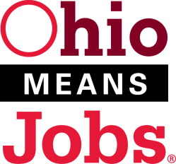 |  |  | Ohio Valley Employment Resource
 |  |  | PO Box 181
 |  |  | Marietta, OH 45750
 | Proudly serving Monroe, Morgan, Noble & Washington Counties, since 2000

Workforce Innovation and Opportunity Act Policy Letter No. 15-06 (Determination of Dependent Status)

- Purpose

The purpose of this policy is to outline the process for determining if an applicant or member of a family is dependent on, or independent of, his/her parents(s) or guardian(s).

It will be the policy of the Workforce Development Board to follow the most recent State policy 15-06 (Determination of Dependent Status) with the following additions highlighted in yellow:

- Effective Date with WDB and COG motion #s

July 1, 2015; COG motion 9-15 on 1/25/16; WDB motion 10-15 on 12/14/15

- Background
- Definitions
- Requirements

WDB Policy Requirements
All youth under age 25 and all adults under age 25 that are applying for WIOA adult-funded individual training accounts must have dependent status documented in the participant’s file using the area’s Dependency Status form or a similar form including all data requested on the area’s form.

- Monitoring
- Technical Assistance

At the county level, it is the county’s discretion to contact the state directly or to start with the Area Executive Director. However, regardless of choice, the Area Executive Director must be consulted, whether directly or by cc: on email, so that the WDB is informed and engaged in local implementation.

